Logan Watanabe

67-328

Homework 4

**Overview**

For the assignment this week I made a page that loads the NFL teams and their latest news stories from ESPN. I used the ESPN developer API to pull the headlines of the news stories. The page can be found at:

<https://blank-cawobu.backliftapp.com/nfl/index>

**Same Origin AJAX**

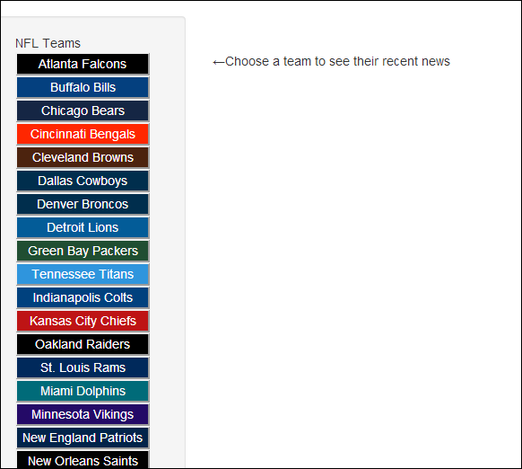 When the document is loaded, the page makes a request to the json file “nfl_teams.json” which is data I got from the ESPN developer site and saved it locally. The data basically has an object for each NFL team, which includes things like their abbreviation, primary color, etc. I process the request by generating the sidebar, which takes the team name and color to make a button. It also creates an id using the team abbreviation.

**Cross Origin AJAX**

When a user clicks on a team button on the side, the page sends a request to the ESPN developer API and receives an object that includes team headlines and news. The ESPN developer website can be found at <http://developer.espn.com/>. They make articles, teams, and athlete data available to the public, and more in-depth stats and rosters for partner developers.

Using a global variable of all the teams, I am able to get the id ESPN uses for that team and make a request to only receive the headlines for the news articles related to that team. I iterate through them to generate headlines, picture, description, and a link to the full story and show them on the page. Initially, you can only see the headlines, but if you click on it then it will slide out and you can see the picture, description and link. (screenshot on next page).

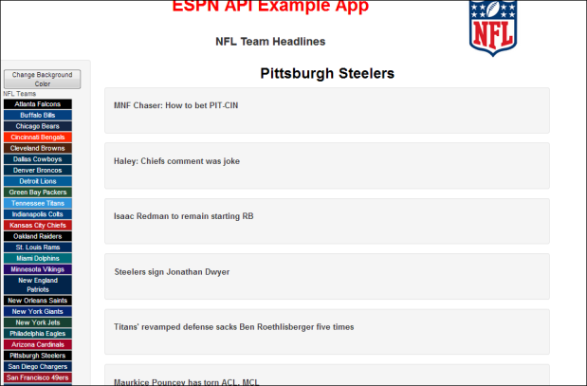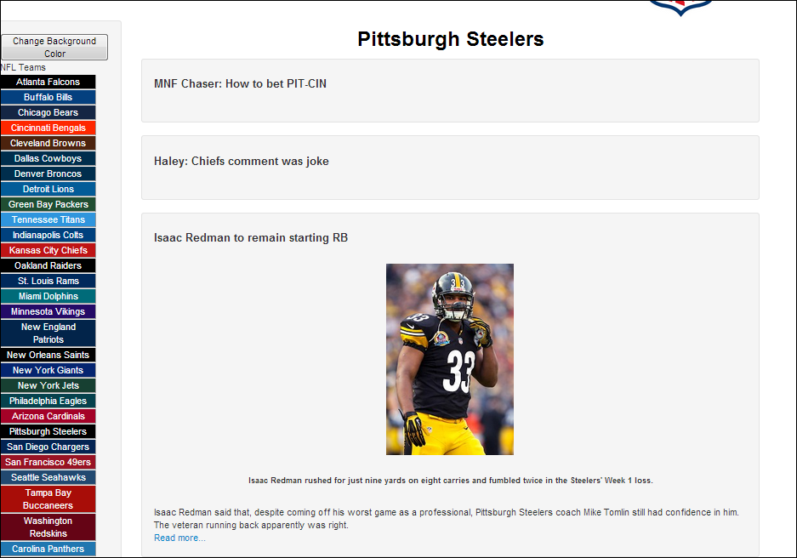

**3 Points Of User Interaction (3 event handlers)**

The first point of user interaction is when they click a team’s button on the sidebar to load their headlines. My javascript grabs the text of the button and searches the global variable nfl_teams to find the corresponding object. Then it carries out a request using the team id to load the headlines. (see screenshot above)

The second point of user interaction is clicking on a headline to expand and see the picture and description. When a user clicks on a headline, the javascript slides the content out, and also slides in any other news content, so only one story is shown at a time. Also, if the expanded headline is clicked again, it will slide the news content back up. (see screenshot above)

The third point of user interaction is clicking the button “change background color” which appears after a team is chosen. What this button does is changes the body background color to whatever team was picked, or if it was already changed, it changes it back to white. I store the color in a global variable. It ain’t much, but it is user interaction.

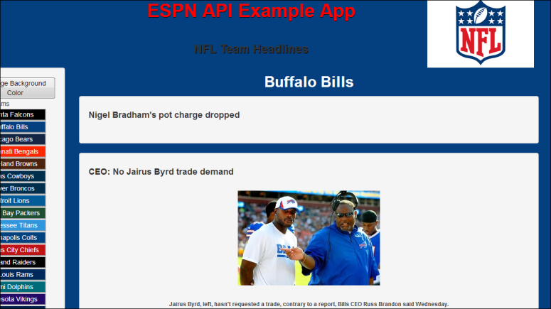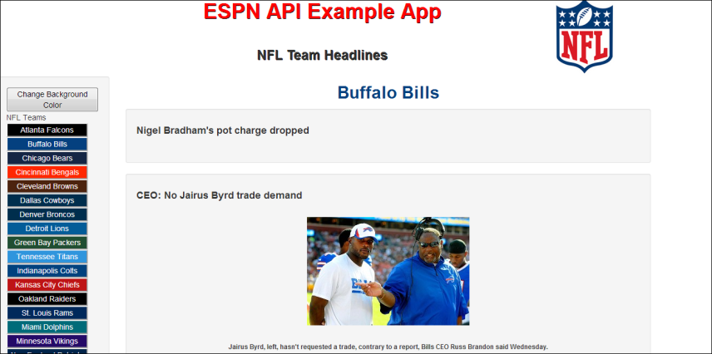

**10 uses of jQuery**

I used lots of jQuery in my code, but here are 10 examples:

1. I used the jQuery on document ready $(function…) (line 7).
2. Used the normal selector to find the “nfl_list” element and append a button (line 26).
3. Changed the style of the button using the css() method (line 27 & 28).
4. Used the on(“click”…) method to add functionality to the buttons (line 39).
5. Used the empty() method to clear the contents of the body before loading new stuff (42).
6. Used attr(“id”) to get the id/team abbreviation of the button (46).
7. Used filter() method on the nfl_teams object to grab the appropriate team (47).
8. Used show() to make the “change background” button appear (90).
9. Used siblings() and find() to select all other news elements besides the one clicked (102).
10. Used slideToggle() to make the news content come out under the headline (103).

**Bonus Stuff**

I mean, I think this application is useful if you want to see the latest news on a team, but I suppose those kind of sites already exist, like team specific sites. As for visual design, this is just simple, so hopefully the design is clean and simple, which I think it is.